- Create a class called Team that has properties to hold the team name, number of wins, number of draws, number of losses, number of games. All these properties have private setters.
- Add a property called Points which calculates the points based on the values for Wins, Draws and Losses. 3 Points for a win, 1 for a draw and 0 for a loss. You need to use the long hand means of writing a property here as there is a calculation in the getter.
- Create a constructor where the team name is set. It should take in one parameter. In the program.cs file create Team objects for five teams such as the following:
Team SligoRovers = new Team("Sligo Rovers");
Team FinnHarps = new Team("Finn Harps");
Team GalwayUnited = new Team("Galway United");
Team DerryCity = new Team("Derry City");
Team Dundalk = new Team("Dundalk");
- In the program.cs file create an List of type Team to hold all the Team objects and add the Team objects created to the list.
- Create a method in the Team class called DisplayTeamTable. This method which is shown below returns a formatted string with team details.
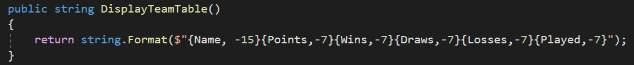
- Create a method in program.cs called DisplayTeams which is passed a List of Teams and displays the details by calling the DisplayTeamTable.
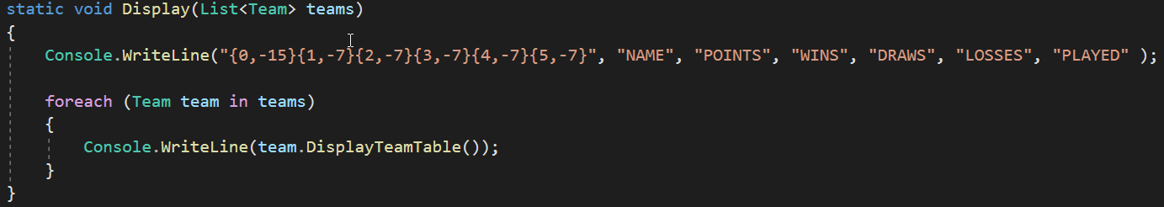
- Use this method to display the league table as shown below.
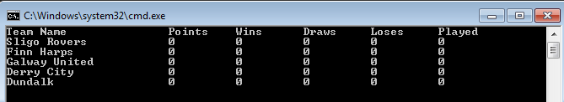

- Create an enum called Result that has 3 elements {Win, Draw, Lose}. (We have not covered this, some research needed).
- Create a method called AddResult in the Team class that takes in one parameter of type Result and depending on the result update the read only properties.

- For each Team object call the AddResult method and supply a Result such as below:

SligoRovers.AddResult(Result.Win);
FinnHarps.AddResult(Result.Loss);
FinnHarps.AddResult(Result.Draw);
GalwayUnited.AddResult(Result.Win);
Dundalk.AddResult(Result.Loss);

- Display the league table as shown below using the Display method previously written.


- Implement the IComparable interface to allow the Team objects be compared based on points.
- Sort the array and then reverse it so the team with the highest points is listed first.
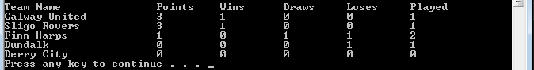

- Add another class called Player. This is a small class that has player name and position as properties. Add a property to Team which is a List of Players. Create some players and add them to the Team. In program.cs display the players on one team.
